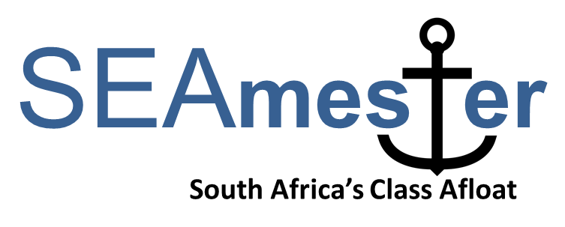

-------------------------------------------------------------------------------------------------
STUDENT APPLICATION FORM – please type in your details
To be returned to Isabelle.Ansorge@uct.ac.za by Friday 5th April 2019*
You will be advised of the outcome on 10th April 2019.
* No late applications will be considered
A) Personal details

First name
Last name
Gender |  | - Male  - Female
Email address
Contact Number
Date of birth
Country of citizenship
Passport number PLEASE NOTE THAT A PASSPORT IS NOT REQUIRED FOR YOUR APPLICATION BUT IF SELECTED YOU WILL NEED A PASSPORT IN TIME FOR THE CRUISE
Expiry Date
Study/Work Visa – expiry date FOR SADC STUDENTS. PLEASE MAKE SURE THAT ANY VISAS ARE VALID 6 MONTHS AFTER SEAMESTER ENDS.
South African ID (if available)
Clothing size | - S  - M  - L  - XL  - XXL
Airport – PLEASE TICK THE CLOSEST AIRPORT TO YOU. PLEASE NOTE STUDENTS RESIDING AT CPUT, UWC, UCT AND SUN DO NOT QUALIFY FOR AIR TRANSPORT | - PORT ELIZABETH  - EAST LONDON  - DURBAN  - OTAMBO – JOHANNESBURG

Name of contact person in case of any emergency
Relationship
Address
Email
Telephone/Mobile number

B) Academic details
Highest qualification achieved | - BSc/Btech  - MSc/Mtech  - PhD  - Intern  - Other _______________________
Name of awarding institution
Name of current institution and department
Current year of study
Target degree
Subject area – WHAT AREAS OF MARINE RESEARCH INTEREST YOU THE MOST?
Title of degree thesis (if applicable)
Supervisor of current degree thesis (if applicable)
Email address of supervisor
Tick preferred teaching stream SEE ATTACHED SEAMESTER DESCRIPTION DOCUMENT FOR BOTH STREAMS TO GET AN IDEA OF THE LECTURE LAYOUT.  PLEASE NOTE - ONCE YOU HAVE BEEN SELECTED YOU WILL NOT BE ABLE TO CHANGE YOUR STREAM. | - Option 1 – Oceans in a Changing World  - Option 2 - Tools of the Trade
How did you hear about SEAmester? | - Friend/Social media  - HoD/Supervisor  - University/Technikon Newsletter  - SANCOR  - Other _______________________________
Have you applied to SEAmester before  Please note preference will be gven to students who have not particpated on a SEAmester programme before. | - 2016  - 2017  - 2018  - No

C) Previous sea-going experience (max 150 words). It is not compulsory for students to have had previous sea-going experience.

D) Motivation - please include how you would benefit from this course (max 250 words).

E) Short Biography of yourself – no more than 4 sentences. Please include a photo.

F) Endorsement from either HoD or Supervisor - (max 50 words).

Acdemic Institute ________________________ Position ____________________________

Comment __________________________________________________________________
______________________________________________________________________________________________________________________________________________________

Signature _______________________________ Date ______________________________

F) Email address of HoD or Supervisor (signatory of E above). Your performance report will be emailed directly to this person.

G) Sign and date this application to indicate that you have read and understand the SEAmester programme and verify that all the information contained herein is factually correct.

Signature _______________________________ Date ______________________________

Please prepare one pdf document and label file (SEAmester and your Name and Institute) i.e. SEAmester-Ansorge–UCT.
CHECK LIST
Please tick each box to ensure you pdf file contains all the necessary doucments

Included
- Application form
- Endorsement from HoD or supervisor
- Email address for your performance report to be sent to
- Proof of registration at current university or technikon
- Recent academic transcript
- Copy of valid passport IF AVAILABLE
- Copy of valid ID
- Photograph of yourself
- Short Biography

Understand
- That you have read all attached documentation
- That an incomplete application form will not be considered
- That the final deadline is Friday 5th April 2019 and no late applications will be considered

